--1.COUNT
SELECT COUNT(*) AS Total_Employees
FROM EMPLOYEES;

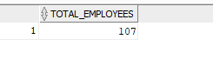

--COUNT TOTAL NUMBER OF DEPARTMENTS
SELECT COUNT(*) AS TOtal_Departments
FROM DEPARTMENTS;

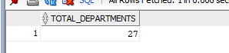

--2.SUM
--TOTAL SALARY FOR EMPLOYEES
SELECT SUM(SALARY) AS Total_Salary
FROM EMPLOYEES;
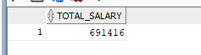

----TOTAL COMMISSION PERCENTAGE
SELECT SUM(COMMISSION_PCT) AS Total_Commission
FROM EMPLOYEES;
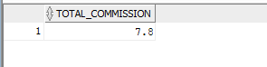

--3.AVG
--AVERAGE SALARY OF ALL EMPLOYEE
SELECT ROUND(AVG(SALARY), 2) AS Avg_Salary
FROM EMPLOYEES;
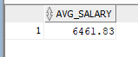
--AVERAGE MINIMUM SALARY FROM JOBS
SELECT ROUND(AVG(MIN_SALARY) , 2) AS Avg_Min_Salary
FROM JOBS;
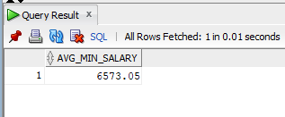

----AVERAGE MAXIMUM SALARY FROM JOBS
SELECT ROUND(AVG(MAX_SALARY) , 2) AS Avg_Max_Salary
FROM JOBS;
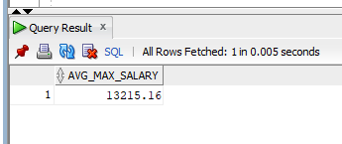

----4.MAX & MIN

--HIGHEST AND LOWEST SALAYR FROM EMPLOYEES
SELECT MAX(SALARY) AS Highest_Salary,
MIN(SALARY) AS lOWERST_Salary
FROM EMPLOYEES;
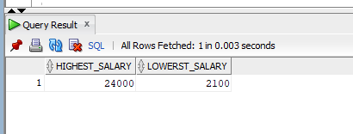

--HIGHEST AND LOWEST MAX_SALARY from JOBS
SELECT MAX(MAX_SALARY) AS Highest_Max_Salary,
MIN(MAX_SALARY) AS Lowest_Max_Salary
FROM JOBS;
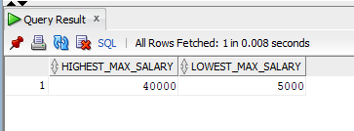

---5.GROUP BY
--GROUP EMPLOYEES BY DEPARTMENT, SHOW TOTAL PER DEPARTMENT
SELECT DEPARTMENT_ID,
COUNT(*) AS Total_Employees
FROM EMPLOYEES
GROUP BY DEPARTMENT_ID
ORDER BY DEPARTMENT_ID;
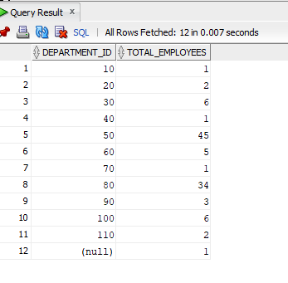
--GROUP JOBS BY TITLE, SHOW AVERAGE MIN AND MAX SALARY
SELECT JOB_TITLE,
ROUND(AVG(MIN_SALARY), 2) AS Avg_Min_Salary,
ROUND(AVG(MAX_SALARY), 2) AS Avg_Max_Salary
FROM JOBS
GROUP BY JOB_TITLE
ORDER BY JOB_TITLE;
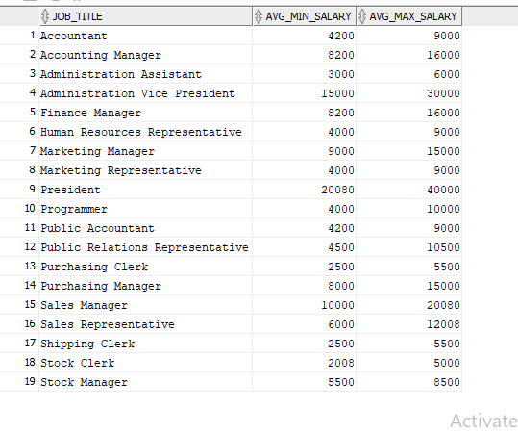

--6.HAVING
--DEPARTMENT WITH MORE THAN 5 EMPLOYEES

SELECT DEPARTMENT_ID,
COUNT(*) AS Total_Employees
FROM EMPLOYEES
GROUP BY DEPARTMENT_ID
HAVING COUNT(*) > 5
ORDER BY Total_Employees DESC;

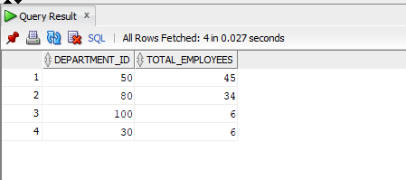

--JOBS WHERE AVERAGE MAX SALARY EXCEEDS 10000
SELECT JOB_TITLE,
ROUND(AVG(MAX_SALARY), 2) AS Avg_Max_Salary
FROM JOBS
GROUP BY JOB_TITLE
HAVING AVG(MAX_SALARY) > 10000
ORDER BY Avg_Max_Salary DESC;
